1. Create a React Application “eventexamplesapp” to handle various events of the form elements in HTML.
2. Create “Increment” button to increase the value of the counter and “Decrement” button to decrease the value of the counter. The “Increase” button should invoke multiple methods.
   1. To increment the value
   2. Say Hello followed by a static message.
3. Create a button “Say Welcome” which invokes the function which takes “welcome” as an argument.
4. Create a button which invokes synthetic event “OnPress” which display “I was clicked”. Create a “CurrencyConvertor” component which will convert the Indian Rupees to Euro when the Convert button is clicked. Handle the Click event of the button to invoke the handleSubmit event and handle the conversion of the euro to rupees.

CODE:

CurrencyConverter.js

import React, { useState } from 'react';

const CurrencyConverter = () => {

  const [rupees, setRupees] = useState('');

  const [euros, setEuros] = useState(null);

  const handleSubmit = (e) => {

    e.preventDefault();

    const conversionRate = 0.011;

    setEuros((rupees \* conversionRate).toFixed(2));

  };

  return (

    <div>

      <h2>Currency Converter</h2>

      <form onSubmit={handleSubmit}>

        <input

          type="number"

          value={rupees}

          onChange={(e) => setRupees(e.target.value)}

          placeholder="Enter amount in INR"

          required

        />

        <button type="submit">Convert</button>

      </form>

      {euros && <p>{rupees} INR = {euros} EUR</p>}

    </div>

  );

};

export default CurrencyConverter;

App.js

import React, { useState } from 'react';

import CurrencyConverter from './components/CurrencyConverter';

import './App.css';

function App() {

  const [count, setCount] = useState(0);

  const [message, setMessage] = useState('');

  const increment = () => {

    setCount(count + 1);

    alert('Hello, member!');

  };

  const decrement = () => {

    setCount(count - 1);

    setMessage('');

  };

  const sayWelcome = (text) => {

    alert(`Welcome, ${text}!`);

  };

  const handlePress = (e) => {

    alert('I was clicked');

    console.log('Synthetic Event:', e);

  };

  return (

    <div className="App">

      <h1>Event Examples App</h1>

      <h2>Counter: {count}</h2>

      <button onClick={increment}>Increment</button>

      <button onClick={decrement}>Decrement</button>

      <button onClick={() => sayWelcome('User')}>Say Welcome</button>

      <button onClick={handlePress}>OnPress</button>

      <p>{message}</p>

      <CurrencyConverter />

    </div>

  );

}

export default App;

App.css

.App {

  text-align: center;

  padding: 20px;

}

button {

  margin: 10px;

  padding: 10px 20px;

  font-size: 16px;

}

input {

  padding: 8px;

  margin: 10px;

  font-size: 16px;

}

OUTPUT:

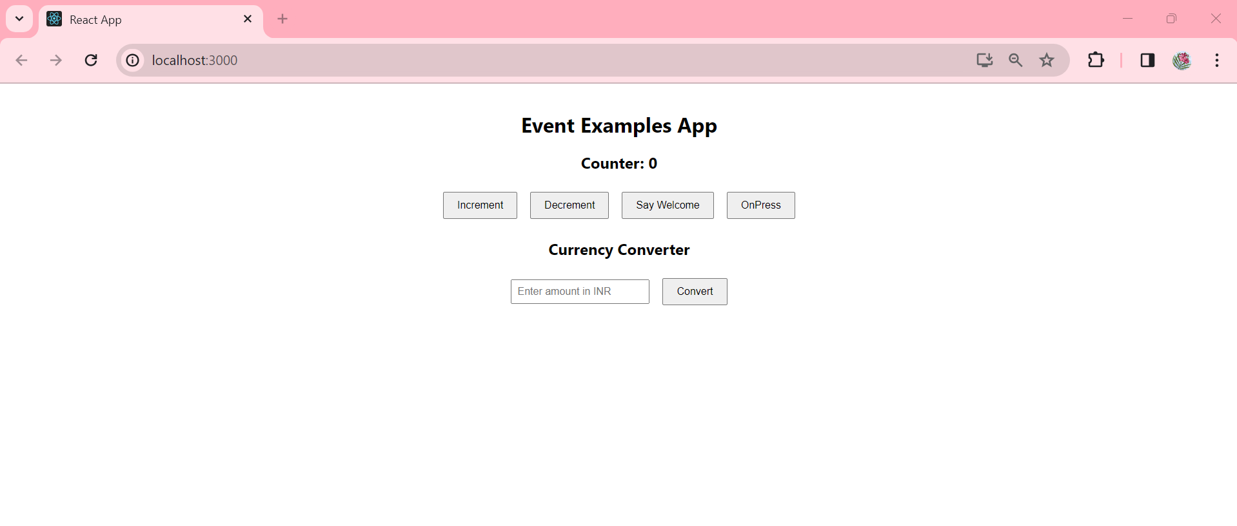

1. 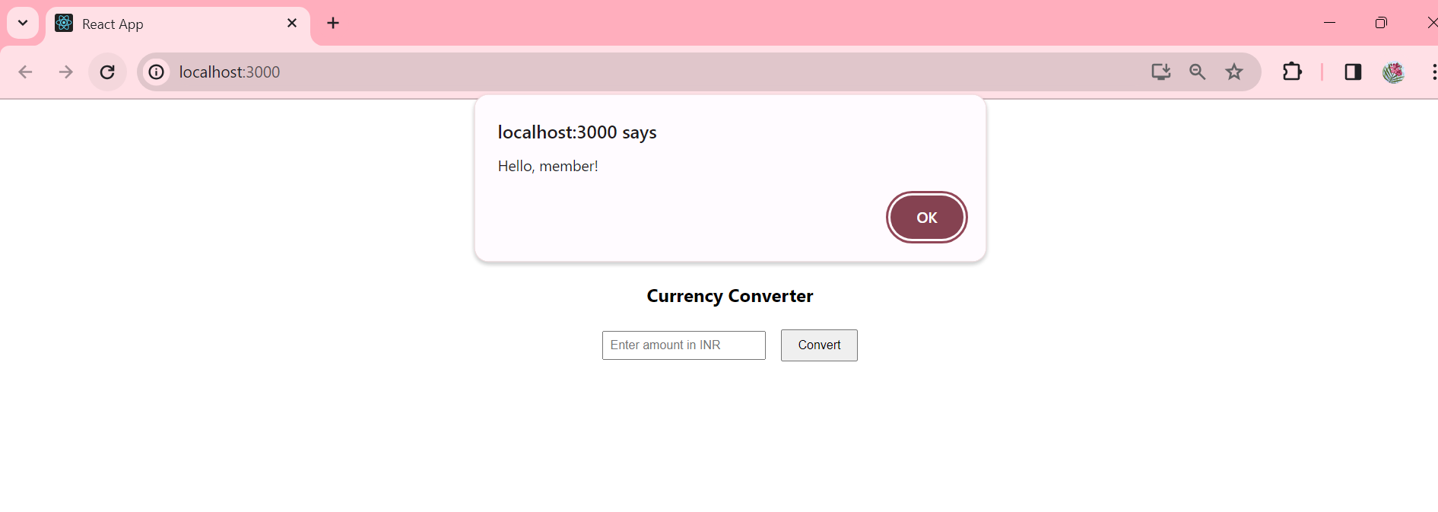
2. 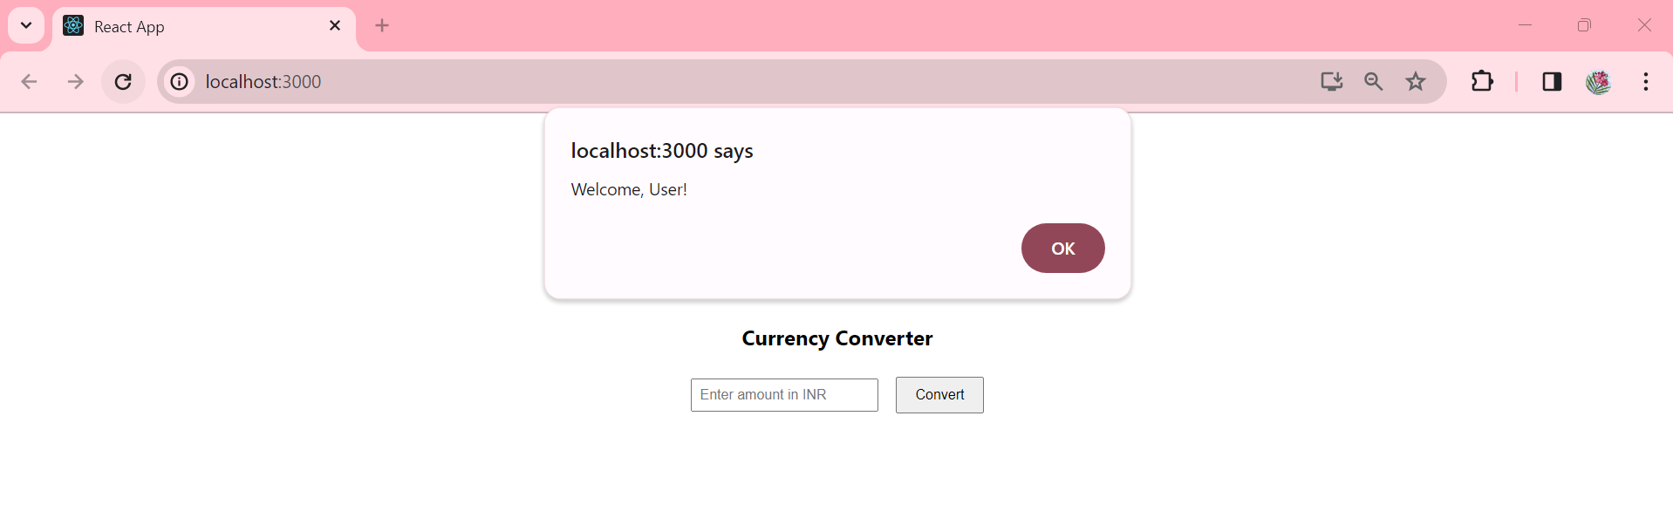
3. 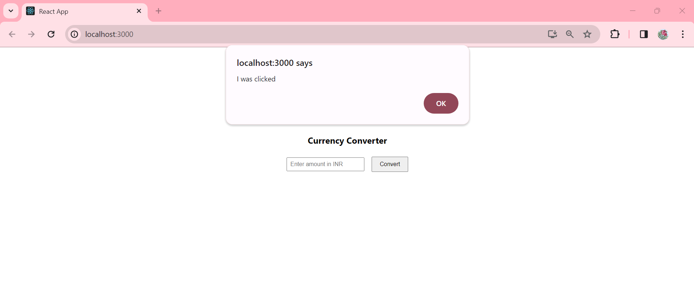

4.